**Use Case: Setting up Transit Gateway and VPC Endpoints for a Multi-VPC ArchitectureScenario:**

**A large organization is migrating its on-premises infrastructure to the AWS cloud.**  
**The organization's architecture involves multiple VPCs for different departments and applications,**  
**each requiring secure communication with centralized services and external resources.**  
**The IT team needs to design and implement a scalable and efficient network architecture to accommodate**  
**the organization's growth and ensure robust connectivity between VPCs and external services.**

**Note:**  
**Create 4 Vpc's in 4 different regions and setup transit gateway.**  
**Do not use default vpc's.**

**I have created 4 VPC’s in 4 different regions and created ec2 server and attached the routs of remaining 3 VPCs RT’S**

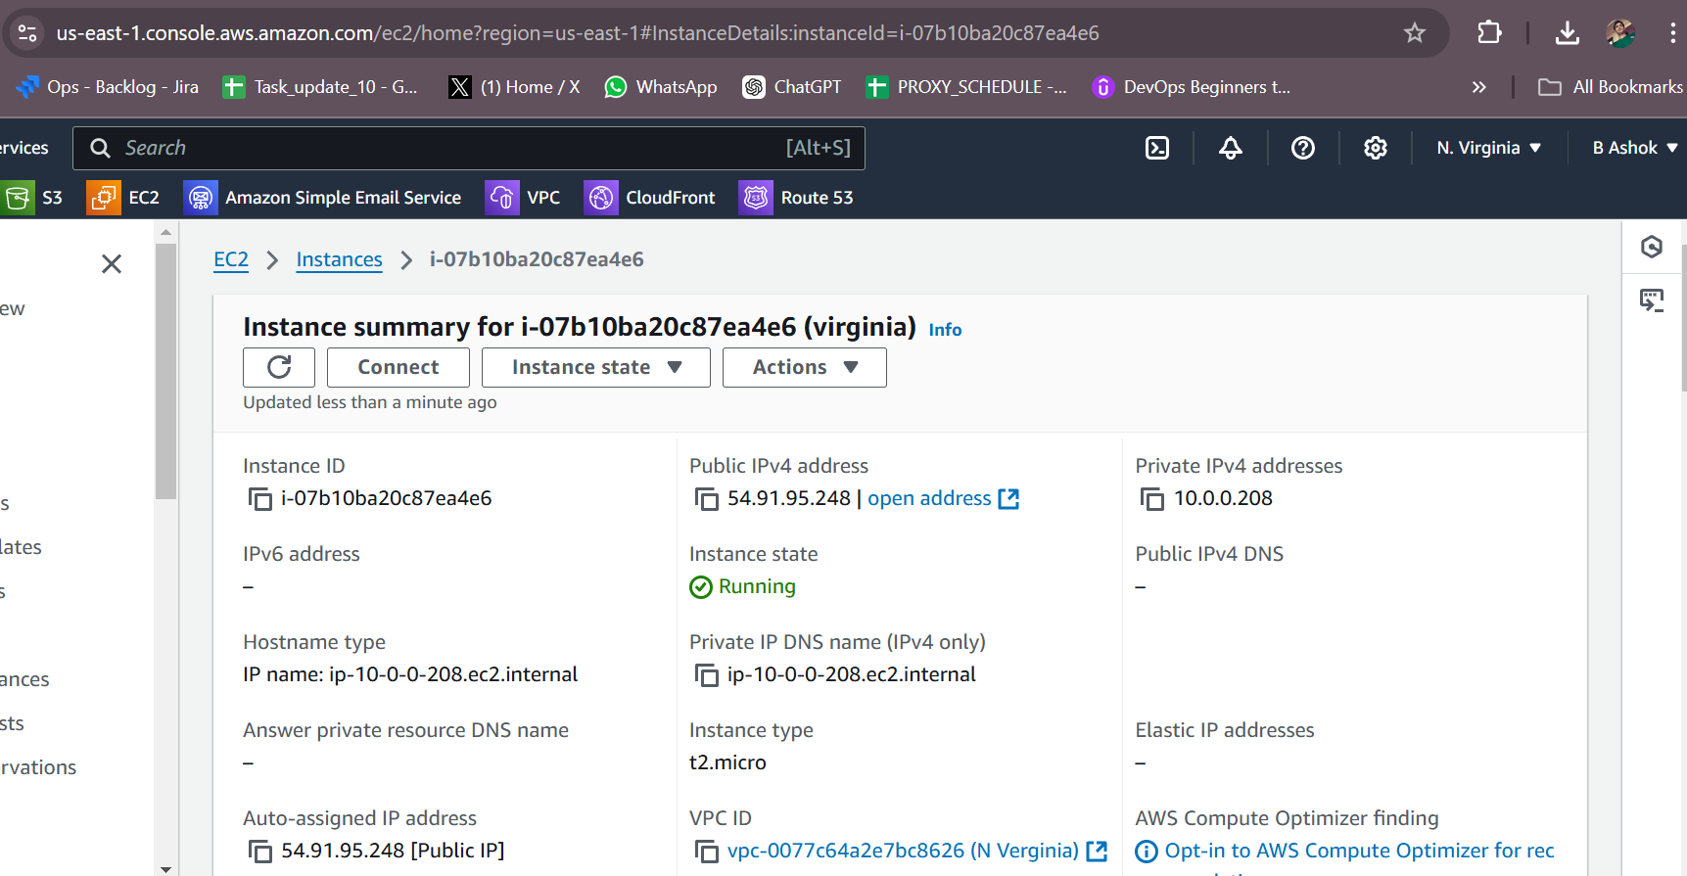

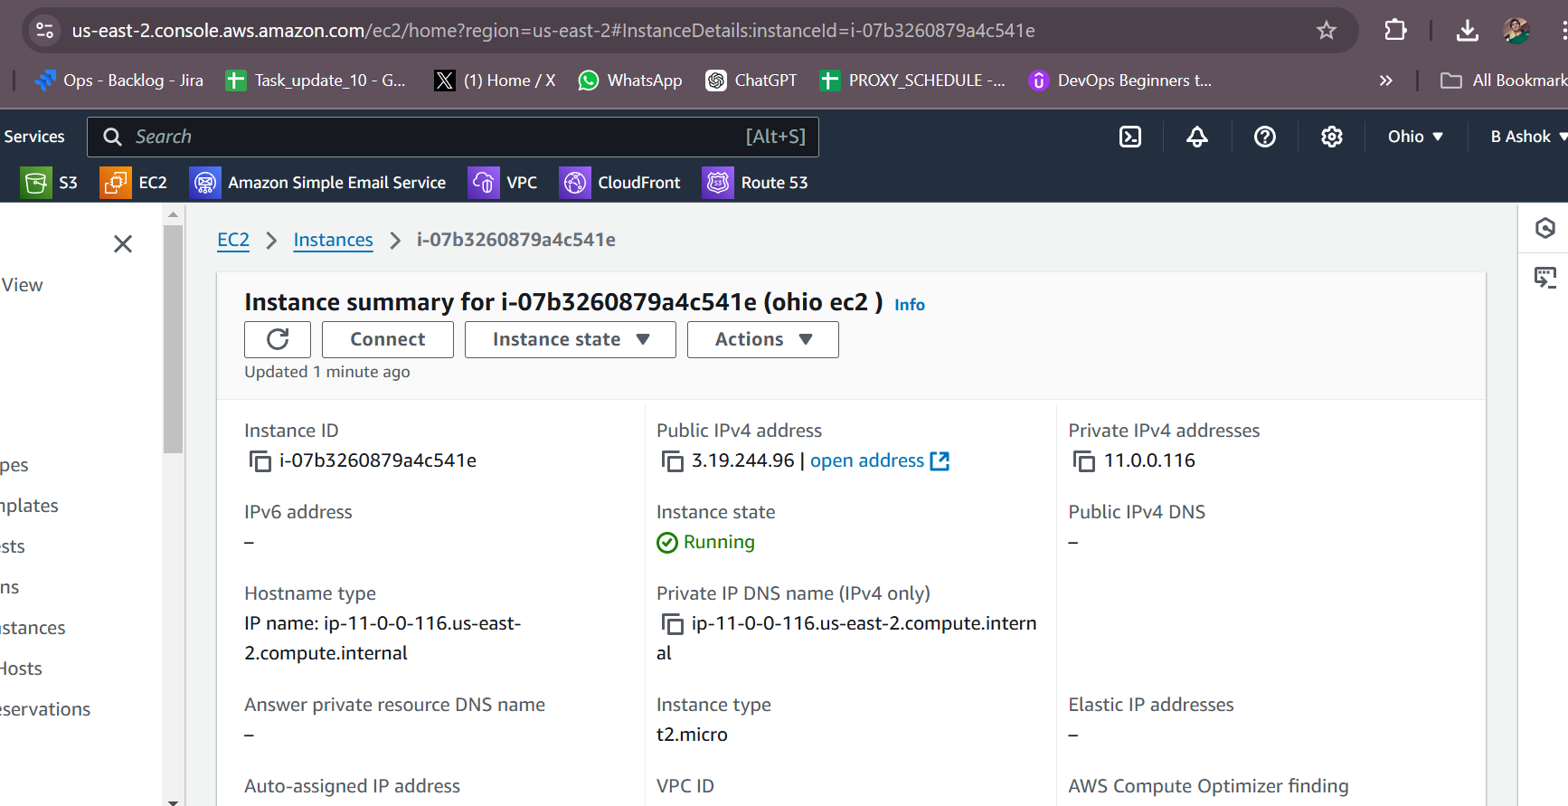

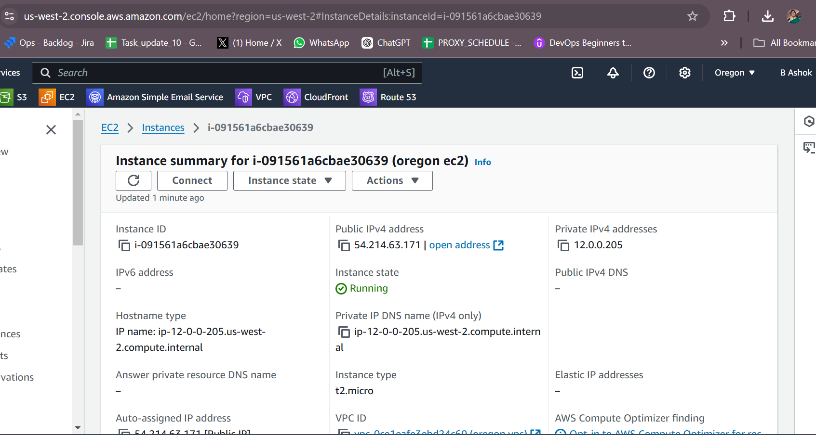

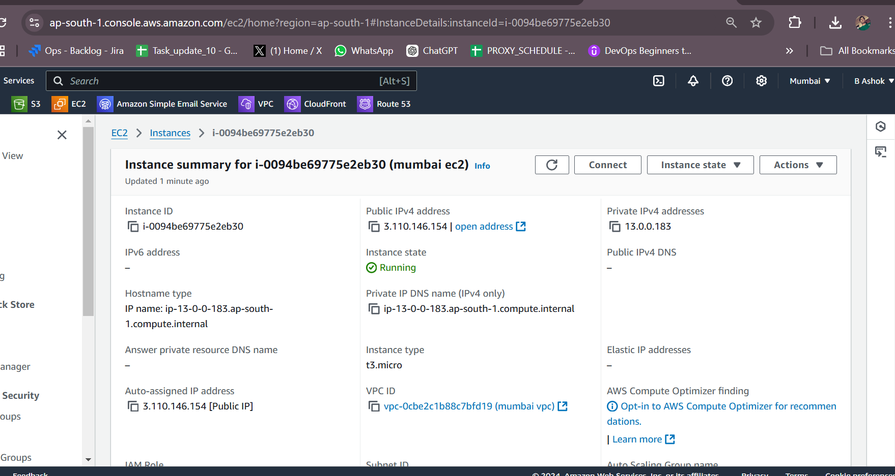

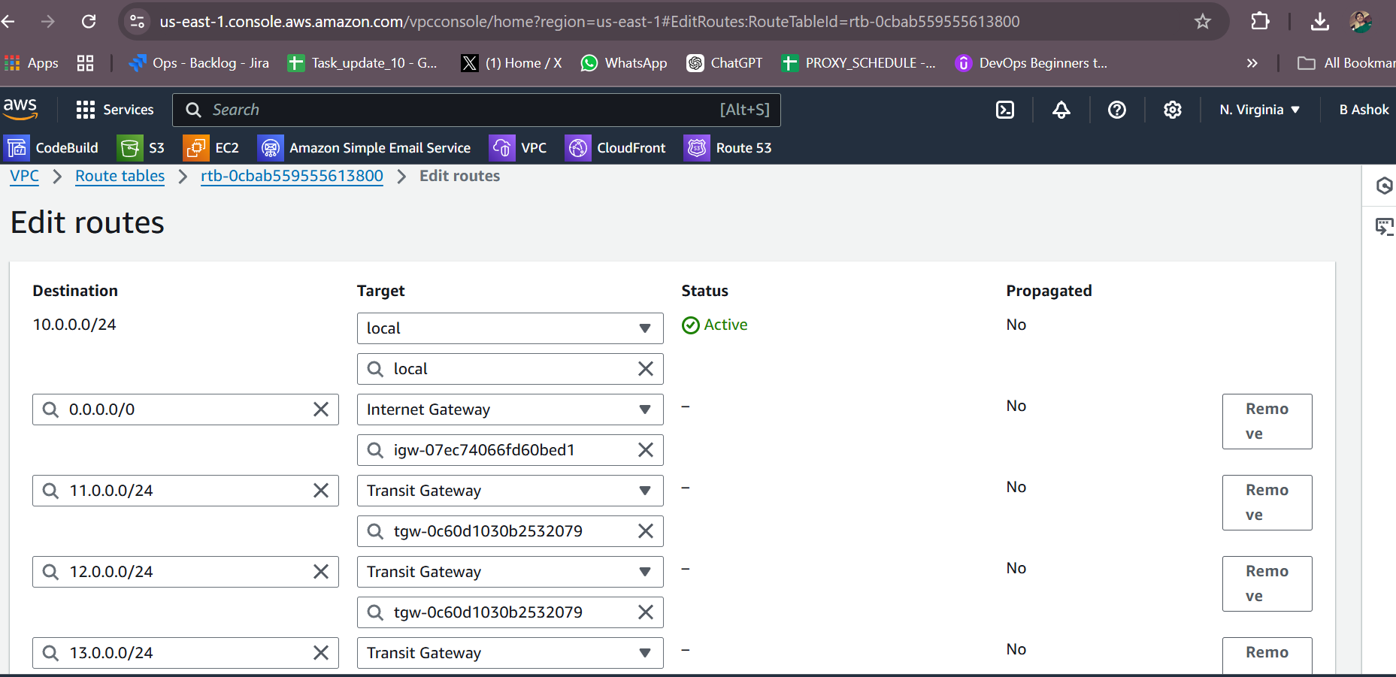

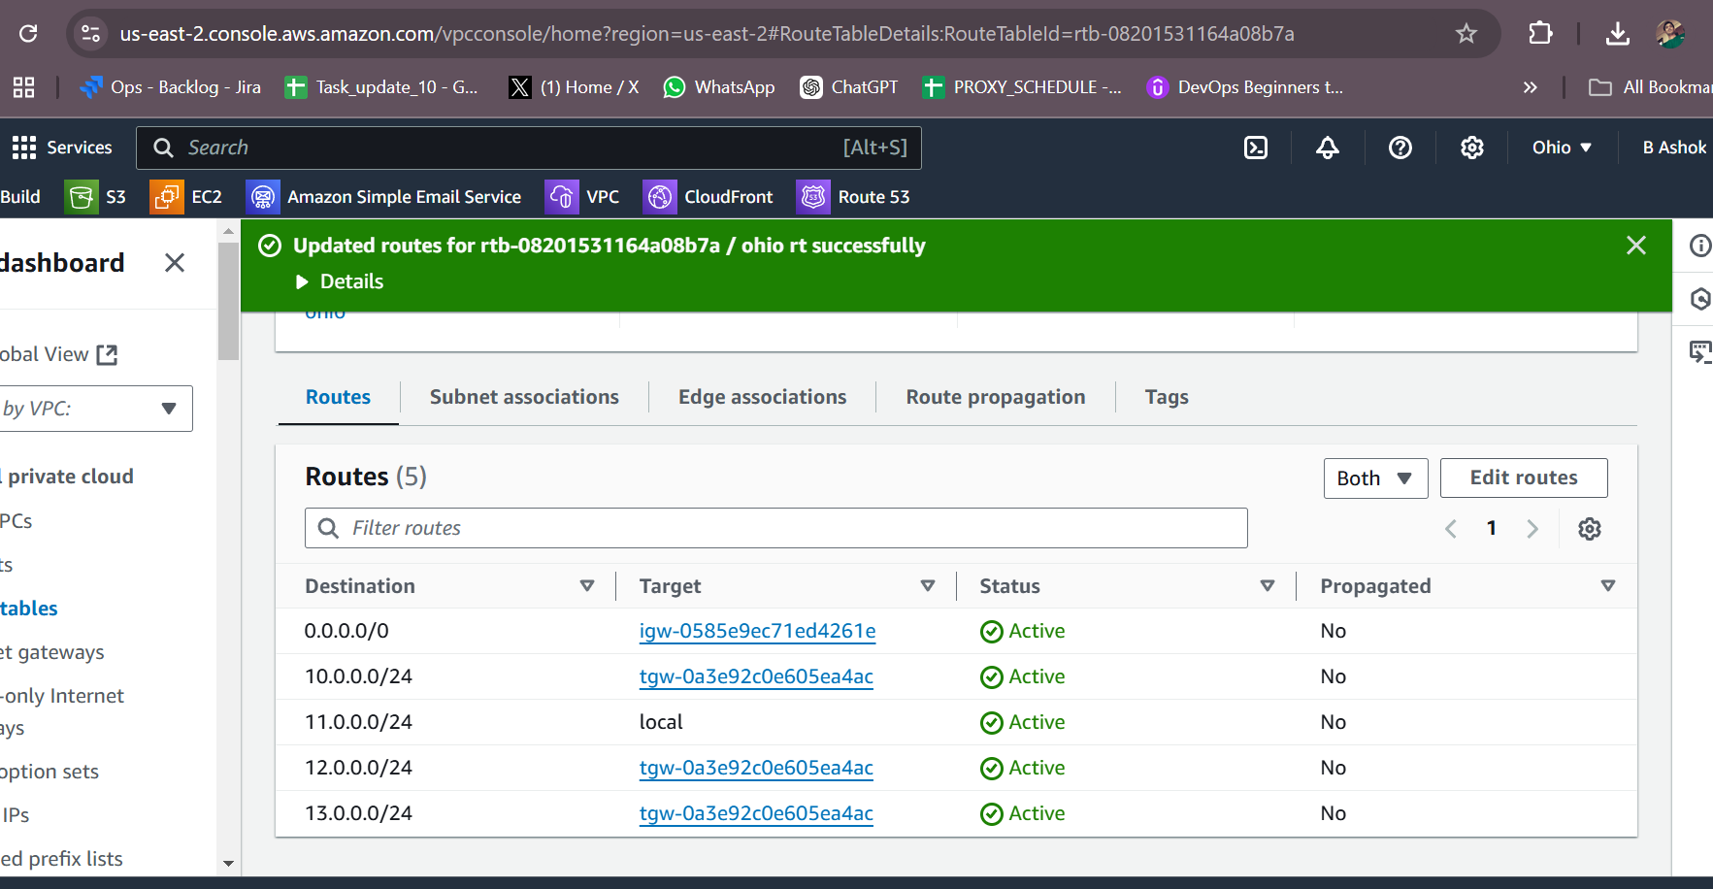

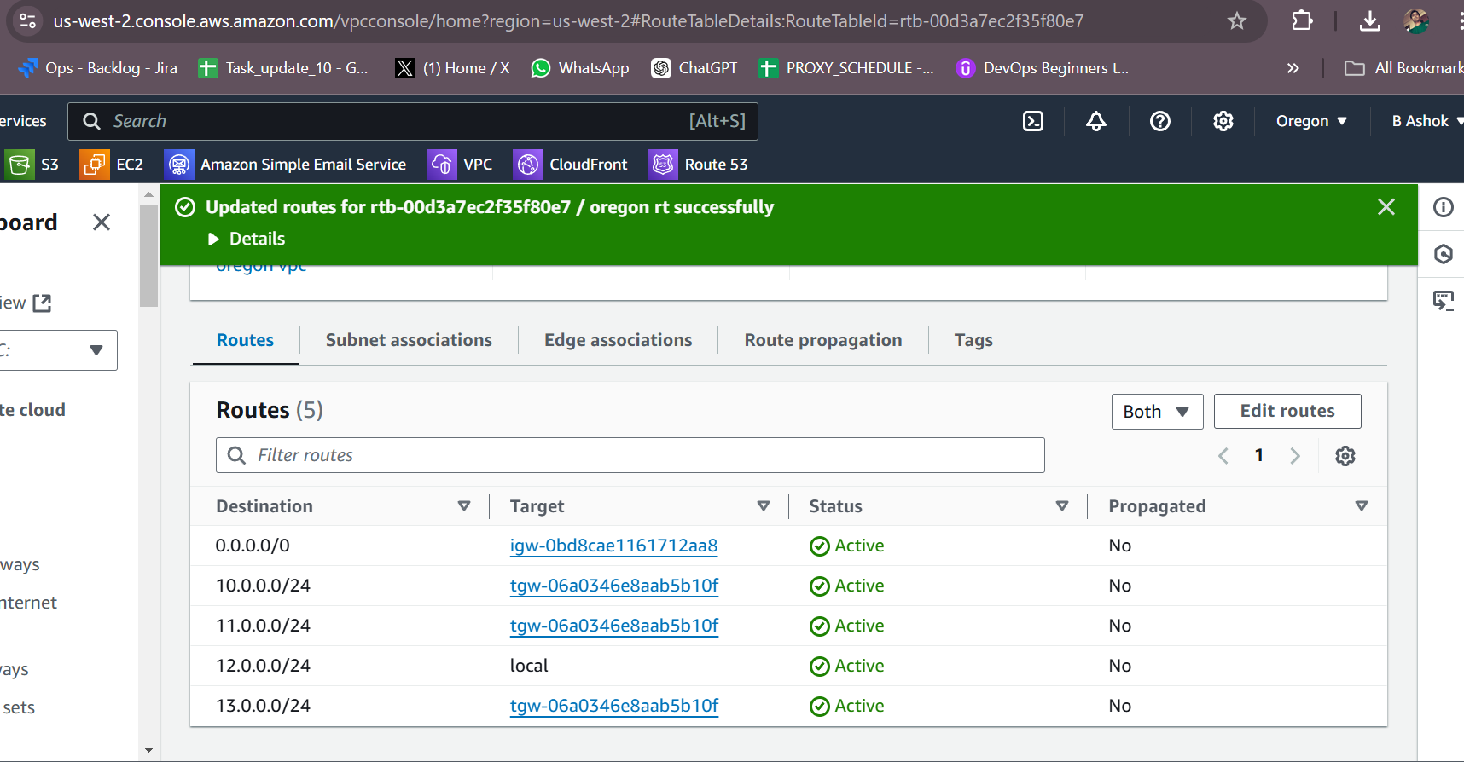

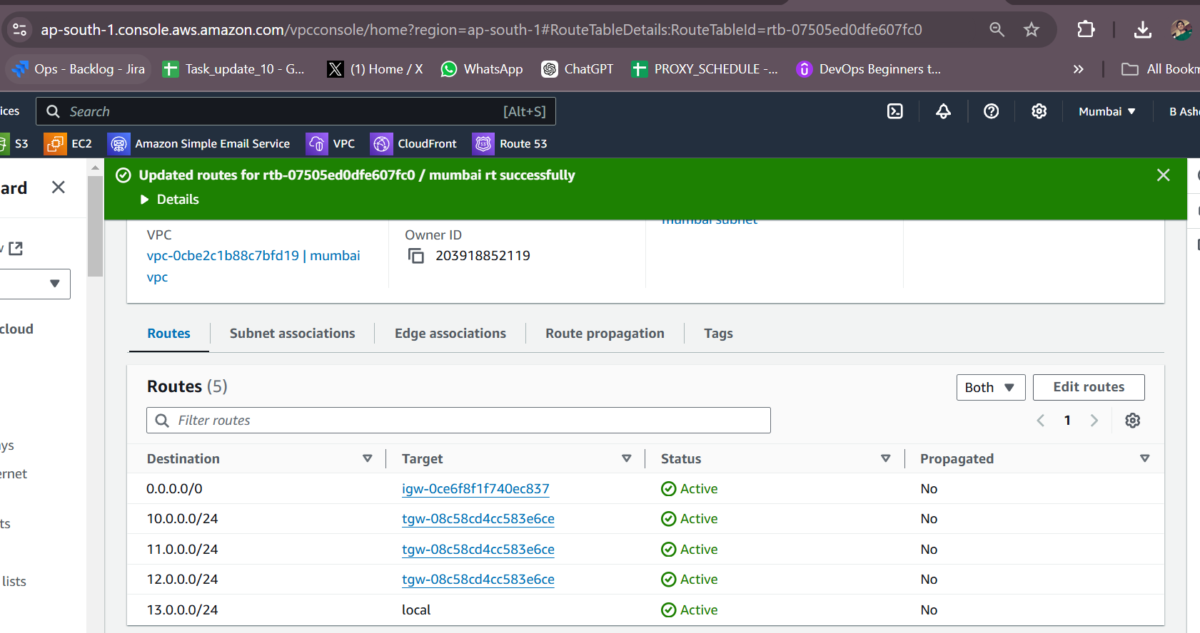

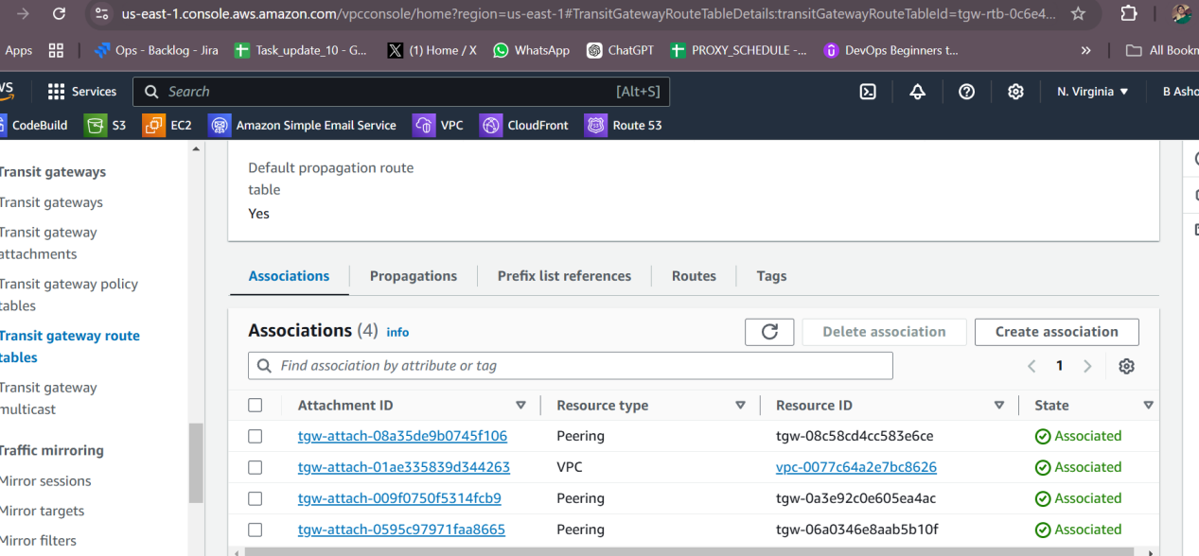

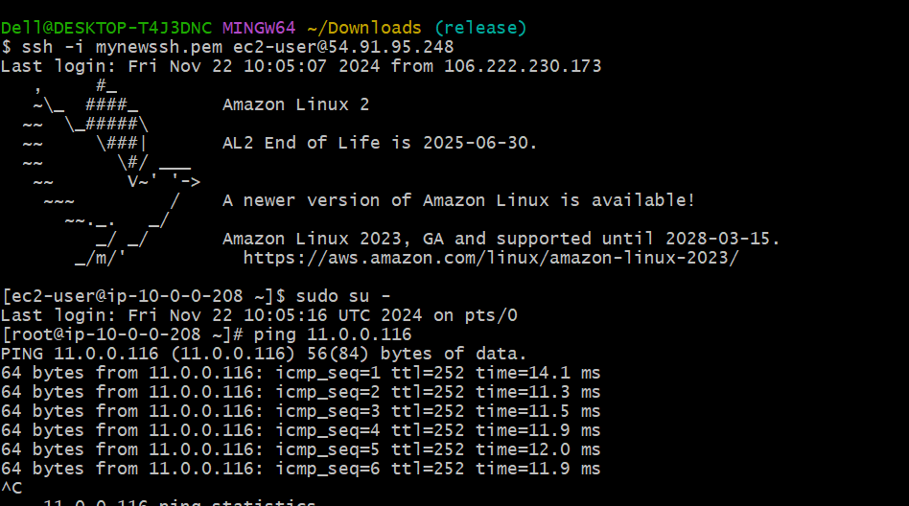

Configure VPC endpoints to securely access AWS services without internet gateways or NAT gateways, ensuring data privacy and minimizing exposure to external threats.

